Project Design Phase-II

Data Flow Diagram & User Stories

|  |  |
| --- | --- |
| Date | 13 October 2022 |
| Team ID | PNT2022TMID07468 |
| Project Name | Project – Estimate crop yield using data analytics |
| Maximum Marks | 4 Marks |

# Data Flow Diagrams:

A Data Flow Diagram (DFD) is a traditional visual representation of the information flows within a system. A neat and clear DFD can depict the right amount of the system requirement graphically. It shows how data enters and leaves the system, what changes the information, and where data is stored.

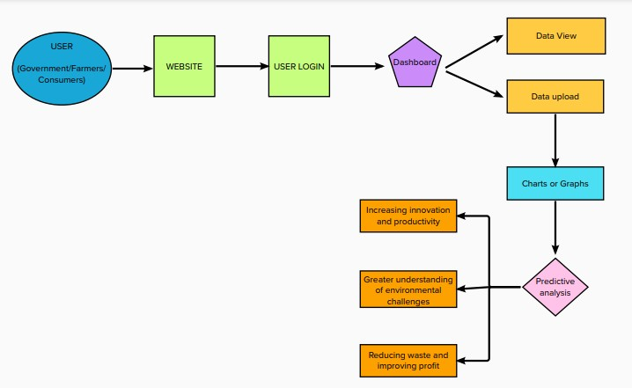

# User Stories

Use the below template to list all the user stories for the product.

|  |  |  |  |  |  |  |
| --- | --- | --- | --- | --- | --- | --- |
| **User Type** | **Functional Requirement (Epic)** | **User Story Number** | **User Story / Task** | **Acceptance criteria** | **Priority** | **Release** |
| Customer (Mobile user) | Registration | USN-1 | As a user, I can register for the application by entering my personal  details and creating account using username and password. | I can access my account / dashboard | High | Sprint-1 |
|  |  | USN-2 | As a user, After completed the registration I will receive confirmation message through my registered email id. | I can receive confirmation email | High | Sprint-1 |
|  |  | USN-3 | As a user, I successfully installed the application which is provided | I can register & access the dashboard | Low | Sprint-2 |
|  | Login | USN-4 | As a user, I can logged in my account using my username and password after installed the application. | I can access the dashboard by login into the application. | High | Sprint-1 |
|  | Dashboard | USN-5 | As a User, I can view and access the information in the dashboard. | I can analyse the current activities of crop production | High | Sprint-1 |
| Customer (Web user) |  | WUSN-1 | As a Web User, I can track the activity of visitors to a specific site to see What content is most popular. | The website must work properly and also there should be no error into the information which is  provided. |  |  |
| Customer Care Executive |  | CCE-1 | As customer care executive I will always be available for the interaction with the customer to clarify the queries. | An executive will note down the customers complaints and solve their problems. | High | Sprint-2 |

|  |  |  |  |  |  |  |
| --- | --- | --- | --- | --- | --- | --- |
| **User Type** | **Functional Requirement (Epic)** | **User Story Number** | **User Story / Task** | **Acceptance criteria** | **Priority** | **Release** |
| Administrator |  | ADMIN-1 | As an Administrator, I will manage backup and recovery, data modelling and design, distributed computing, database systems, and a data security. | Administrators can evaluate, design, review and implementing a data and they are also responsible for  updating and maintaining the data. | High | Sprint-2 |